CaseManagement_Change Status of Case_Instance33_26-Jul-2018_08-35-31_AM_EnterTextAction.png

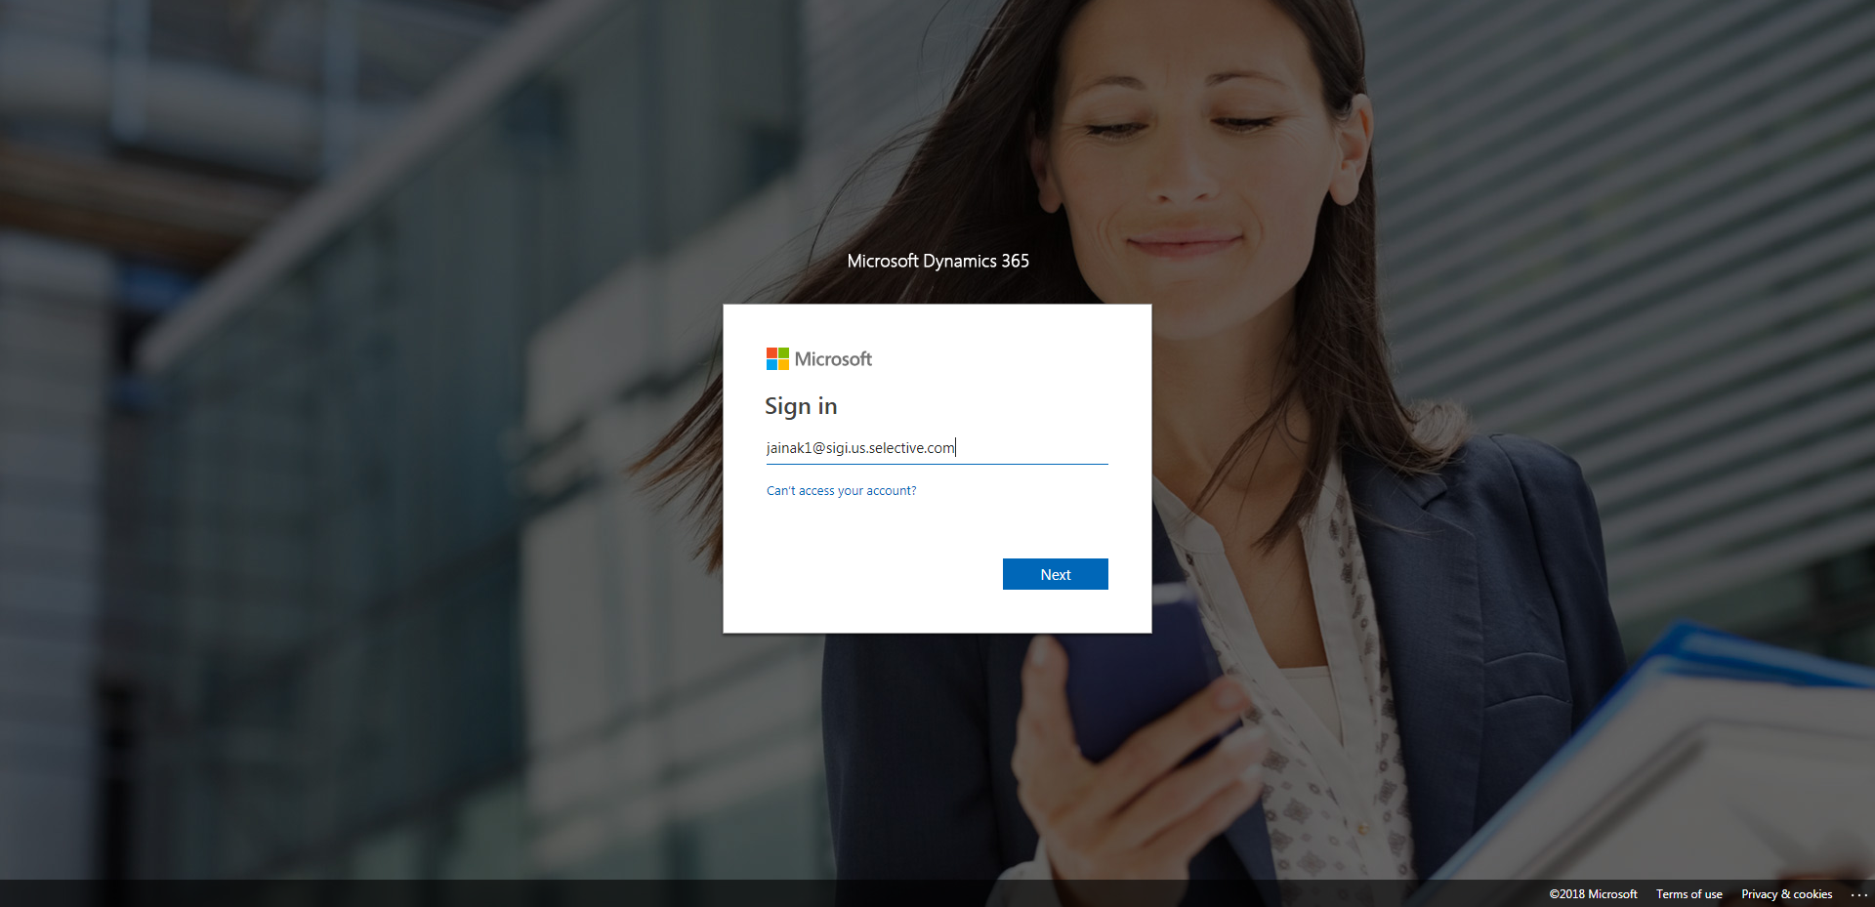

CaseManagement_Change Status of Case_Instance33_26-Jul-2018_08-38-15_AM_VerifyingCaseNotgoingbacktoNEWStatus.png

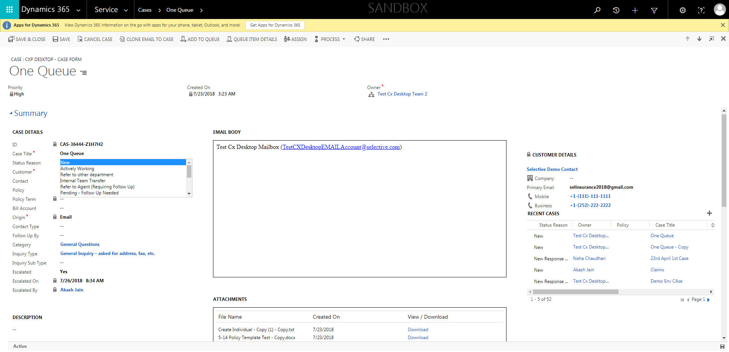

CaseManagement_Change Status of Case_Instance33_26-Jul-2018_08-35-30_AM_MouseClickActiononStaleElement.png

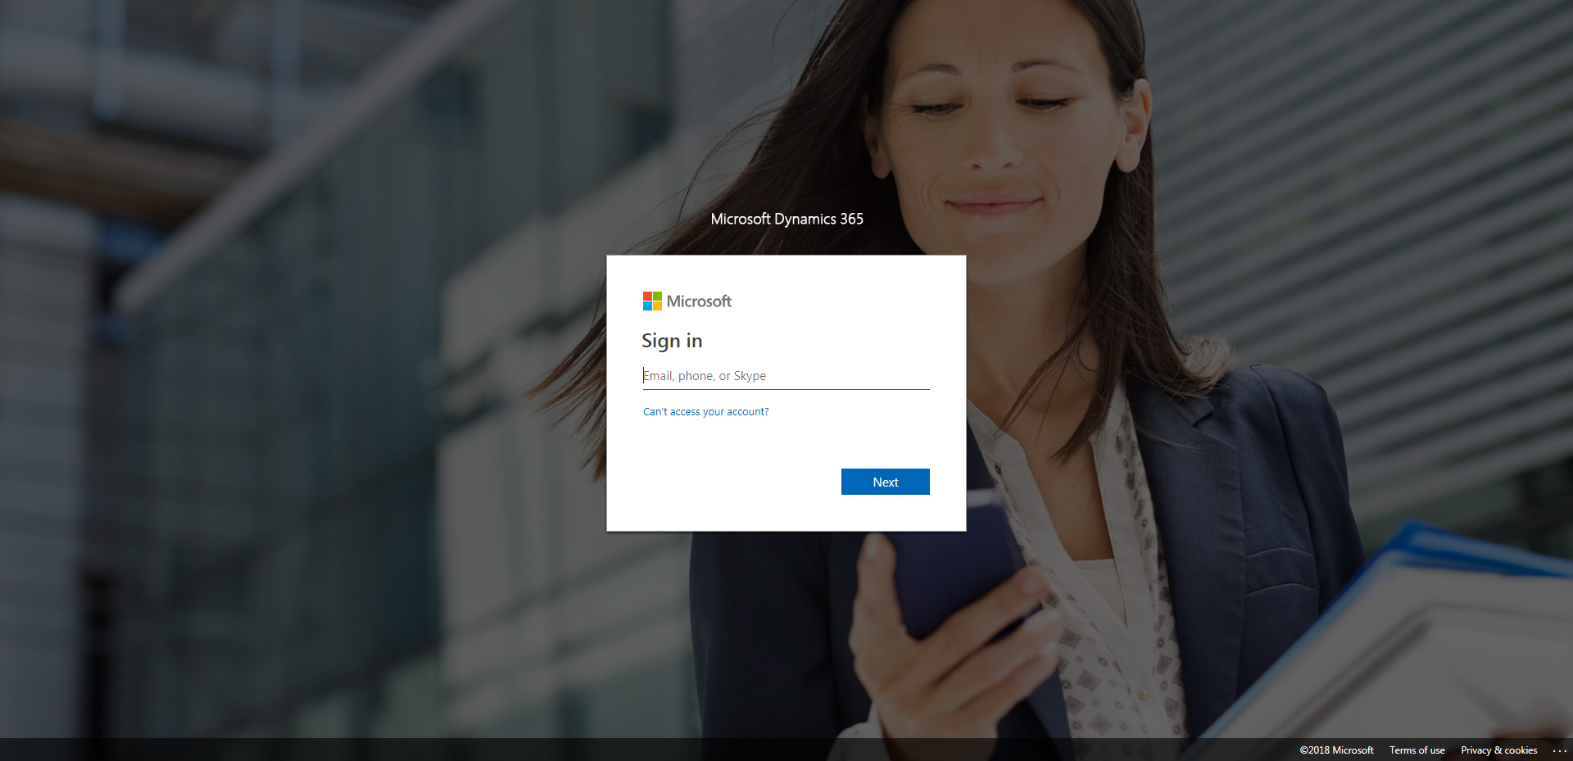

CaseManagement_Change Status of Case_Instance33_26-Jul-2018_08-35-33_AM_MouseClickActiononStaleElement.png

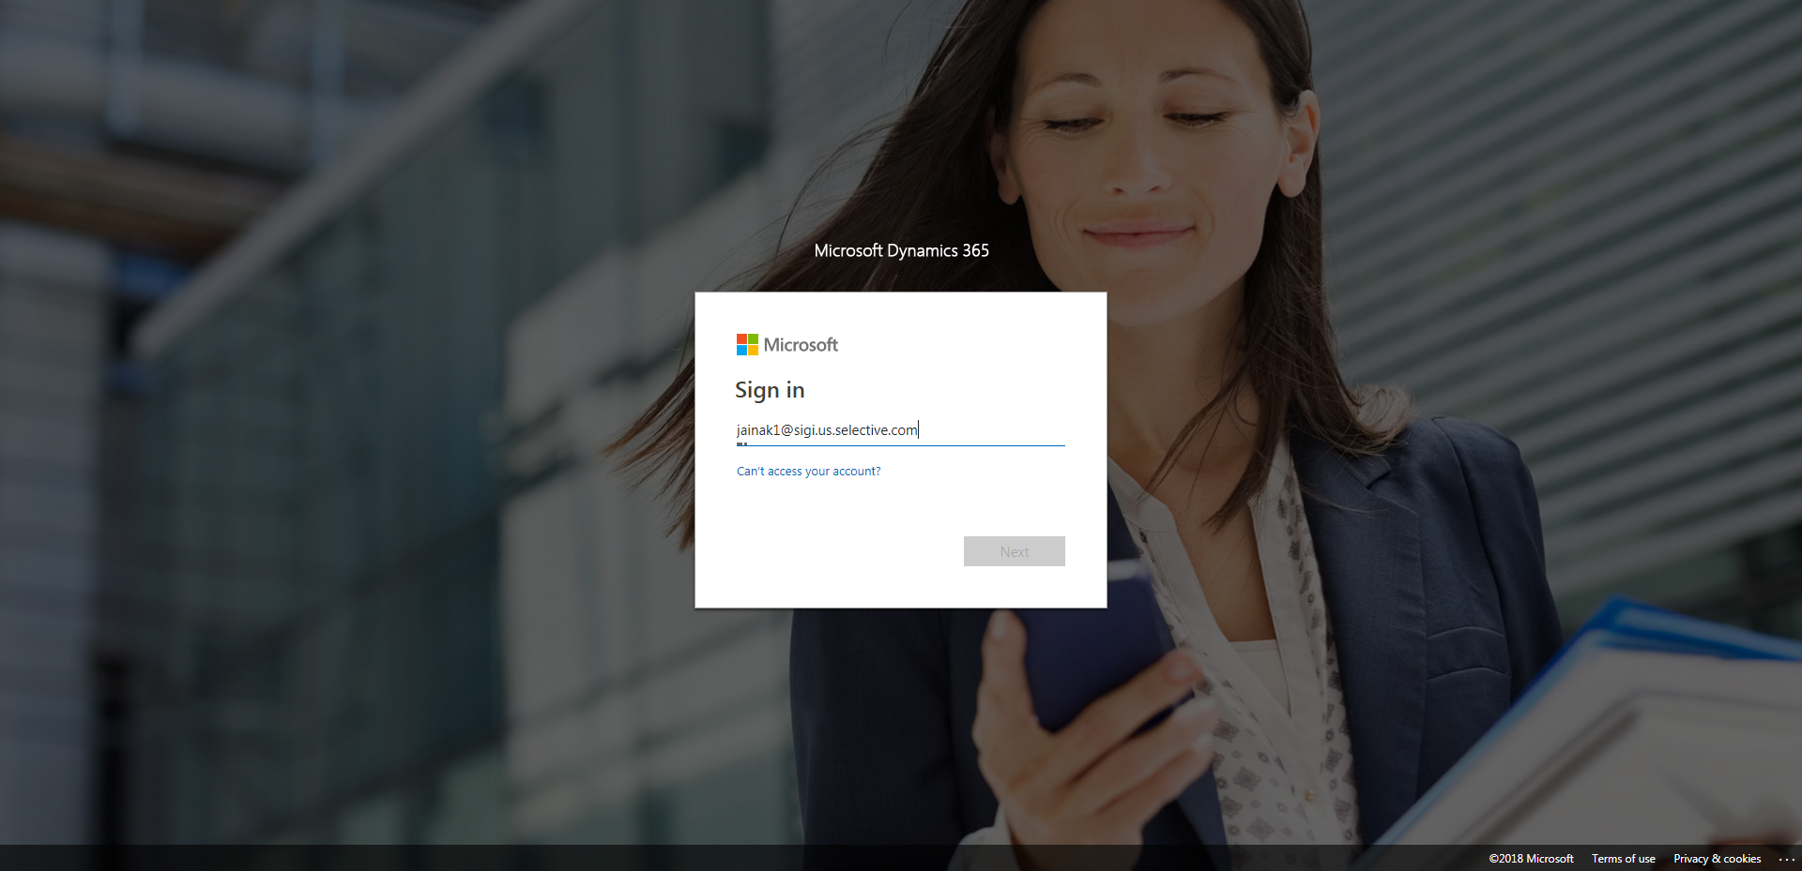

CaseManagement_Change Status of Case_Instance33_26-Jul-2018_08-36-04_AM_SingleSignOn.png

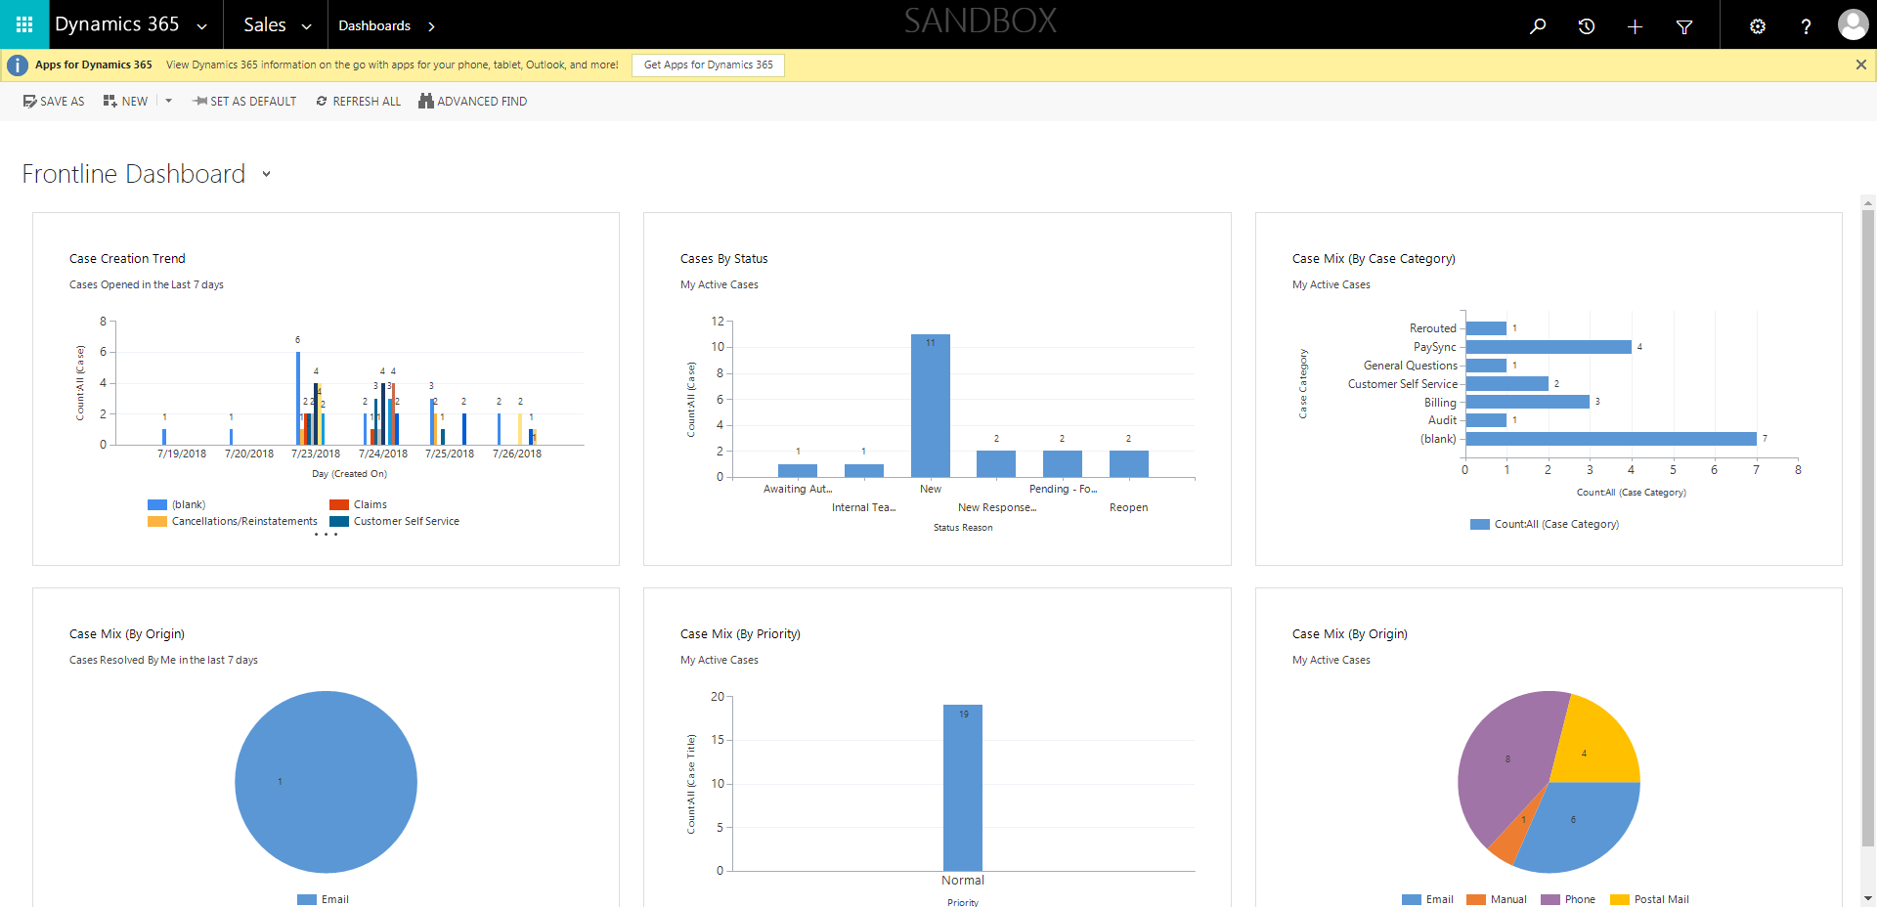

CaseManagement_Change Status of Case_Instance33_26-Jul-2018_08-37-14_AM_ValidatingCaseentitynavigation.png

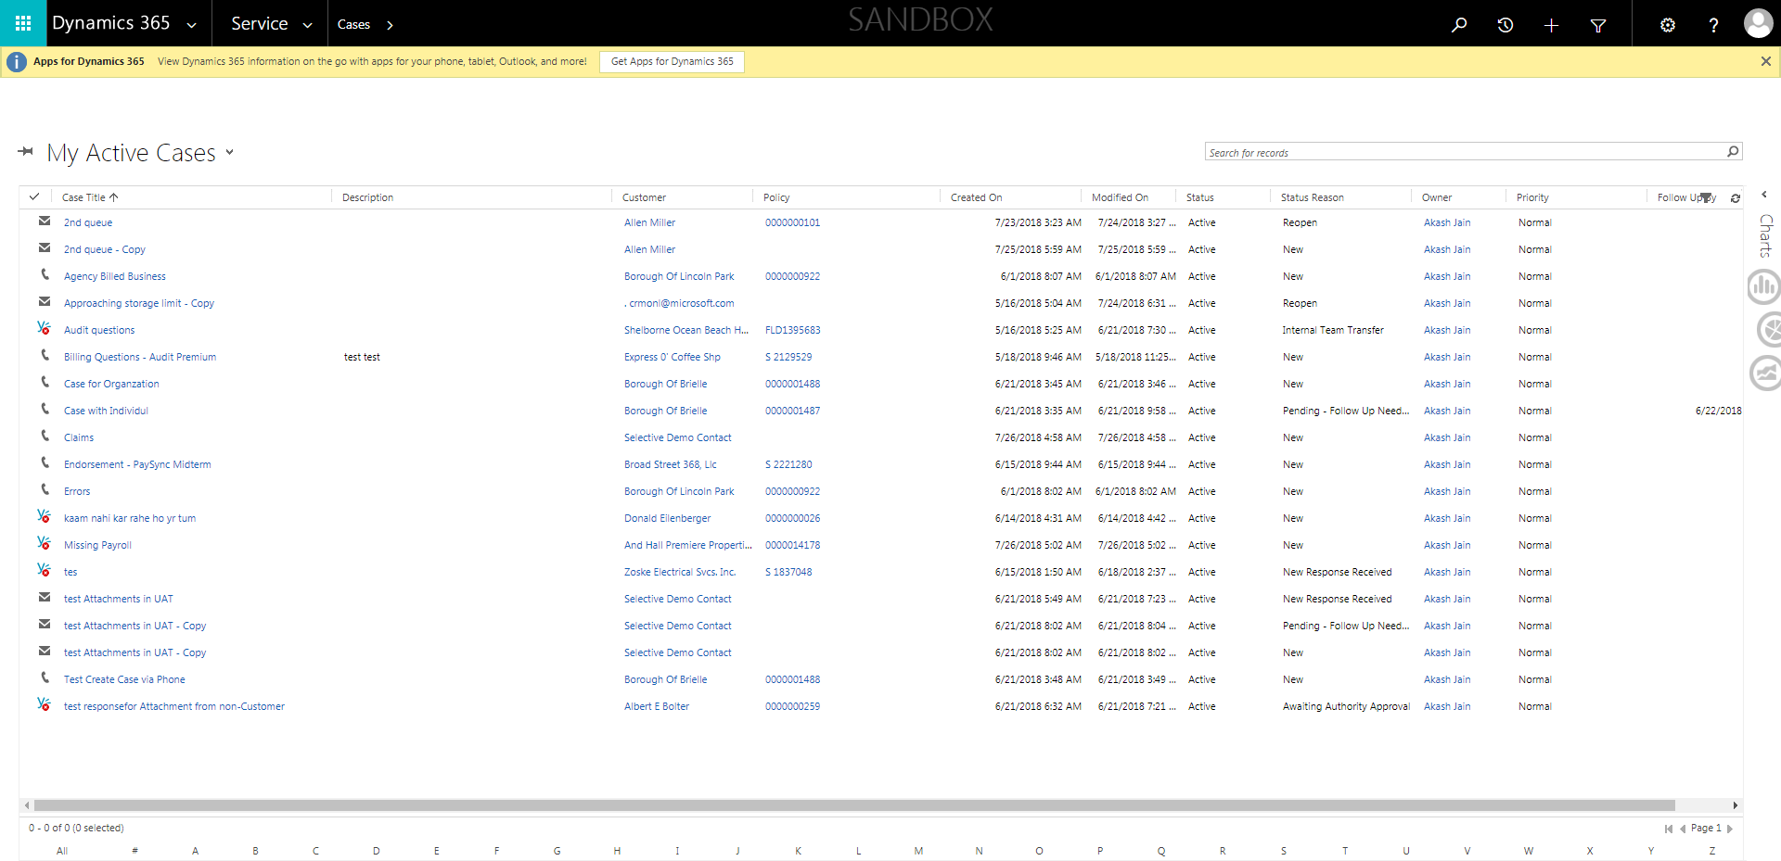

CaseManagement_Change Status of Case_Instance33_26-Jul-2018_08-37-19_AM_ValidatingCaseentitynavigation.png

